Read this IELTS answer and correct the mistakes in the English. Also find one thing wrong with the answer.

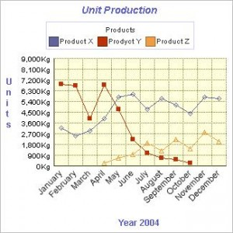

A graph above show production of products during 2004. it detail the out put of three main products, X, Y, and Z in kilogram units, and charts this over the whole calendar year.

production of X is increased in total over the year although the steadily rise of the first six months was not matched in the second half half of the year which saw output flucktuate. The overall positive trend however was positive, and production in the last month of the year only dipped slightly.

Output of product Y has declined dramatical over the year, although after it plumeted in March it recovered to reach a peak in April, before falling rapidly and consistently for the remainder of the year. There is no data provided for the last two months, suggesting that production has ceased totally.

In April production of Z was commenced and has grown steadily until July, when it dipped before recovering to increase until the end of the year, despite of inconsistencies in this increase.

In conclusion, output of these three products has been varied, X and Z having expanded with Y having fallen to zero. This could be because declining demand for Y, or with the introduction as Z as an alternative product.

Now answer these questions:

In which month was there the biggest decline in production on Y?

Did output of X experience a slump?

What happened to production of Y in the final few months of records for that product?

How would you describe the second half of March for product X?

What was the overall trend for Z?

